**ENVIRONMENTAL PROBLEMS IN MYANMAR**

Myanmar faces environmental problems of critical importance to its development. There are a lot of environment issues facing Myanmar.

***Environmental Issues in Myanmar***

Deforestation is the major environmental problem in Myanmar, according to a 1995 report by the Ministry of Forestry. Although 75 percent of Myanmar was once well endowed with natural forest resources, by 1989, only 51 percent of the country remained covered by forests. Nowadays, only 45% of forests left in Myanmar. Sagaing, Shan and Kachin are three states where deforestation occurring at a fast rate compared to other areas.

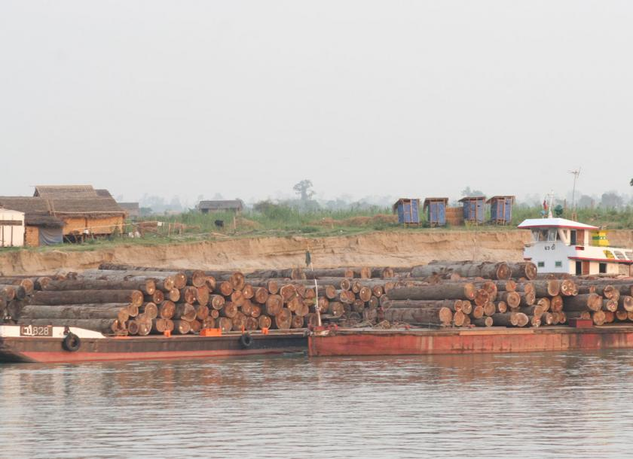

***The reason behind deforestation***

The main reasons for deforestation are excessive cutting to make way for agriculture, and the increasing demand for fuel timber. Deforestation in Myanmar is linked to its growing population and its need for economic development.

***NOTE:*** Other issues such as industrial pollution of water, air and soil are also big problems in Myanmar.

**NATURAL DISASTERS IN MYANMAR**

***Types of natural disasters happening in Myanmar***

* Earthquakes
* Floods
* Landslides
* Tropical cyclones

***Earthquakes***

Earthquakes usually occur in Myanmar. However, most of them are weak and less destructive. But, in 2016, 2 strong earthquakes hit Myanmar. One was in April and one was in August.

April 2016 Myanmar earthquake

A magnitude 6.9 earthquake struck Myanmar 135 km (84 mi) north-west of Mandalay on April 13 with a maximum Mercalli intensity of VI (strong). It struck at 8:25 pm local time and was centered in an isolated area. The estimated depth was 134 km. 2 were died and about 120 people were injured.

August 2016 Myanmar earthquake

A magnitude 6.8 earthquake struck Myanmar 25 km (16 mi) west of Chauk on 24 August 2016 with a maximum Mercalli intensity of VI (strong). It struck at 5:04 pm local time and was centered in an isolated area. The estimated depth was 84.1 km. Tremors from the earthquake were felt in Yangon. According to reports, several temples in the nearby ancient city of Bagan were damaged and four people are reported dead.

***Floods***

Severe flooding in Myanmar began in July 2015 and continued to September, affecting 12 of the country’s states, resulting in about 103 deaths and affecting up to 1,000,000 people. Torrential rains that began on 16 July destroyed farmland, roads, rail tracks, bridges and houses, leading the government to declare a state of emergency on 30 July in the four worst-hit regions in the west: Magway Division, Sagaing Division, Chin State and Rakhine State. Myanmar’s Ministry of Agriculture reported that more than 1.29 million acres of farm land have been inundated and 687,200 acres damaged. Moreover, 15,239 houses were destroyed.

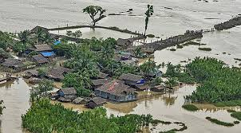

***Landslides***

On 22 November 2015, a major landslide in Hpakant, Kachin state, northern Myanmar killed at least 116 people near a jade mine, with around 100 more missing.

On April 22, 2019, a landslide triggered the collapse of a jade mine near Maw Wun Kalay, Hpakant, Kachin State, Myanmar, trapping at least 54 miners. The deaths of four miners were confirmed, along with the later deaths of two rescue workers. 6 people died in this landslide and more than 50 people were missing.

***Cyclones***

The 2004 [Myanmar](https://en.wikipedia.org/wiki/Myanmar) cyclone was considered the worst to strike the country since 1968. The second [tropical cyclone](https://en.wikipedia.org/wiki/Tropical_cyclone) of the [2004 North Indian Ocean cyclone season](https://en.wikipedia.org/wiki/2004_North_Indian_Ocean_cyclone_season), it formed as a [depression](https://en.wikipedia.org/wiki/Tropical_cyclone_scales#North_Indian_Ocean) on May 16 in the central [Bay of Bengal](https://en.wikipedia.org/wiki/Bay_of_Bengal). With low [wind shear](https://en.wikipedia.org/wiki/Wind_shear) and a surge in the [monsoon trough](https://en.wikipedia.org/wiki/Monsoon_trough), the storm intensified while meandering over open waters. The storm eventually began a steady northeastward motion due to a [ridge](https://en.wikipedia.org/wiki/Ridge_(meteorology)) to the north over [India](https://en.wikipedia.org/wiki/India). While approaching land, an [eye](https://en.wikipedia.org/wiki/Eye_(cyclone))developed in the center of the storm, indicative of a strong cyclone. On May 19, the cyclone made [landfall](https://en.wikipedia.org/wiki/Landfall_(meteorology)) along northwestern Myanmar near [Sittwe](https://en.wikipedia.org/wiki/Sittwe" \o "Sittwe), with [maximum sustained winds](https://en.wikipedia.org/wiki/Maximum_sustained_wind) estimated at 165 km/h (105 mph) by the [India Meteorological Department](https://en.wikipedia.org/wiki/India_Meteorological_Department). The storm rapidly weakened over land, although its remnants spread rainfall into northern [Thailand](https://en.wikipedia.org/wiki/Thailand) and [Yunnan](https://en.wikipedia.org/wiki/Yunnan) province in China.

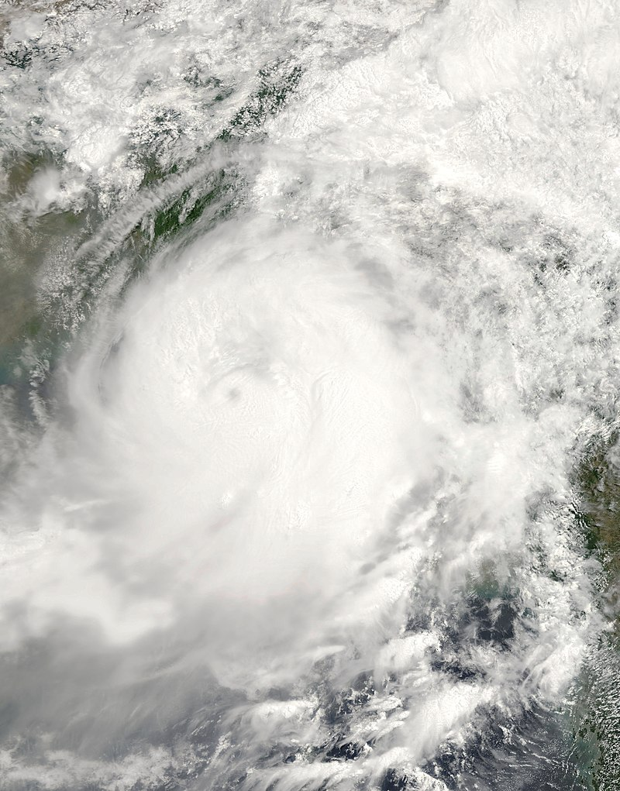

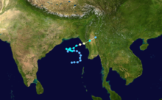

**Extremely Severe Cyclonic Storm Nargis** caused the worst [natural disaster](https://en.wikipedia.org/wiki/Natural_disaster) in the [recorded history](https://en.wikipedia.org/wiki/Recorded_history) of [Myanmar](https://en.wikipedia.org/wiki/Myanmar) during early May 2008.[[1]](https://en.wikipedia.org/wiki/Cyclone_Nargis#cite_note-1) The cyclone made [landfall](https://en.wikipedia.org/wiki/Landfall_(meteorology)) in Myanmar on Friday, 2 May 2008, sending a [storm surge](https://en.wikipedia.org/wiki/Storm_surge) 40 kilometres up the densely populated [Irrawaddy](https://en.wikipedia.org/wiki/Irrawaddy_River) [delta](https://en.wikipedia.org/wiki/River_delta), causing catastrophic destruction and at least 138,373 fatalities.[[2]](https://en.wikipedia.org/wiki/Cyclone_Nargis#cite_note-2)[[3]](https://en.wikipedia.org/wiki/Cyclone_Nargis#cite_note-sigma-3)[[4]](https://en.wikipedia.org/wiki/Cyclone_Nargis#cite_note-BBC_05-16-4) The [Labutta Township](https://en.wikipedia.org/wiki/Labutta_Township" \o "Labutta Township) alone was reported to have 80,000 dead, with about 10,000 more deaths in [Bogale](https://en.wikipedia.org/wiki/Bogale" \o "Bogale). There were around 55,000 people missing and many other deaths were found in other towns and areas, although the Myanmar [government](https://en.wikipedia.org/wiki/State_Peace_and_Development_Council)'s official death toll may have been under-reported, and there have been allegations that government officials stopped updating the death toll after 138,000 to minimise political fallout. The feared 'second wave' of fatalities from disease and lack of relief efforts never materialised.[[5]](https://en.wikipedia.org/wiki/Cyclone_Nargis#cite_note-5) Damage was estimated at over [K](https://en.wikipedia.org/wiki/Burmese_kyat)62,988,000,000 (US$10 billion), which made it the most damaging cyclone ever recorded in this [basin](https://en.wikipedia.org/wiki/Tropical_cyclone_basins).[[6](https://en.wikipedia.org/wiki/Cyclone_Nargis#cite_note-TorontoStar0519-6)

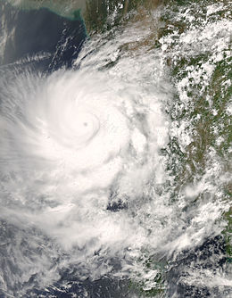

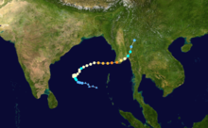

On 1 May 2008, after turning nearly due eastward, Cyclone Nargis began [rapidly intensifying](https://en.wikipedia.org/wiki/Rapid_deepening), due to greatly improved outflow aided by an approaching upper-level [trough](https://en.wikipedia.org/wiki/Trough_(meteorology)).[[26]](https://en.wikipedia.org/wiki/Cyclone_Nargis#cite_note-26) Strengthening continued as Nargis developed a well-defined eye with a diameter of 19 km (12 mi), and early on 2 May, the JTWC estimated that the cyclone reached peak 1-minute winds of 215 km/h (135 mph), as it approached the coast of Myanmar, making it a Category 4 storm.[[27]](https://en.wikipedia.org/wiki/Cyclone_Nargis#cite_note-27) At the same time, the IMD assessed Nargis as attaining peak 3-minute sustained winds of 165 km/h (105 mph).[[28]](https://en.wikipedia.org/wiki/Cyclone_Nargis#cite_note-28) Around 1200 UTC on 2 May, Cyclone Nargis made [landfall](https://en.wikipedia.org/wiki/Landfall_(meteorology)) in the [Ayeyarwady Division](https://en.wikipedia.org/wiki/Ayeyarwady_Division) of Myanmar at peak strength.[[29]](https://en.wikipedia.org/wiki/Cyclone_Nargis#cite_note-29) The storm gradually weakened as it proceeded east over Myanmar, with its proximity to the [Andaman Sea](https://en.wikipedia.org/wiki/Andaman_Sea) preventing rapid weakening. Its track turned to the northeast due to the approach of a mid-latitude trough to its northwest, passing just north of [Yangon](https://en.wikipedia.org/wiki/Yangon) with winds of 130 km/h (80 mph).[[30]](https://en.wikipedia.org/wiki/Cyclone_Nargis#cite_note-disc23-30) Early on 3 May, the IMD issued its final advisory on the storm.[[31]](https://en.wikipedia.org/wiki/Cyclone_Nargis#cite_note-31) Nargis quickly weakened after turning to the northeast, toward the rugged terrain near the Myanmar–Thailand border, and after deteriorating to minimal tropical storm status, the JTWC issued its last advisory on Nargis.[[32]](https://en.wikipedia.org/wiki/Cyclone_Nargis#cite_note-32)

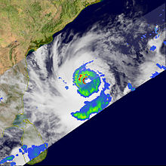

The [United Nations](https://en.wikipedia.org/wiki/United_Nations) estimated that 1.5 million people were "severely affected" by Nargis.[[38]](https://en.wikipedia.org/wiki/Cyclone_Nargis#cite_note-38) Estimates of the people missing were 53,836, with 84,537 confirmed dead.[[3]](https://en.wikipedia.org/wiki/Cyclone_Nargis#cite_note-sigma-3) Some [NGOs](https://en.wikipedia.org/wiki/Non-governmental_organization) estimated that the final death toll would be over 100,000.[[39]](https://en.wikipedia.org/wiki/Cyclone_Nargis#cite_note-39) At least 10,000 people were reported to have perished in the delta town of [Bogale](https://en.wikipedia.org/wiki/Bogale" \o "Bogale) alone.[[40]](https://en.wikipedia.org/wiki/Cyclone_Nargis#cite_note-Reuters_India_080506-40)

Nargis was the deadliest tropical cyclone worldwide since the [Typhoon Nina](https://en.wikipedia.org/wiki/Typhoon_Nina_(1975)) in 1975, which killed at least 229,000 people, and the deadliest tropical cyclone in the North Indian Ocean since the [1991 Bangladesh cyclone](https://en.wikipedia.org/wiki/1991_Bangladesh_cyclone), which killed at least 138,866 people. One [aid worker](https://en.wikipedia.org/wiki/Aid_worker) claimed that the death toll from the cyclone and its aftermath might reach 300,000; if correct, Nargis was the second-deadliest cyclone ever and the fifth-deadliest [natural disaster](https://en.wikipedia.org/wiki/Natural_disaster) of the 20th century, after the [1931 China floods](https://en.wikipedia.org/wiki/1931_China_floods), the [1887 Yellow River flood](https://en.wikipedia.org/wiki/1887_Yellow_River_flood), the [1556 Shaanxi earthquake](https://en.wikipedia.org/wiki/1556_Shaanxi_earthquake), and the [1970 Bhola cyclone](https://en.wikipedia.org/wiki/1970_Bhola_cyclone) in [Bangladesh](https://en.wikipedia.org/wiki/Bangladesh).[[41]](https://en.wikipedia.org/wiki/Cyclone_Nargis#cite_note-41)

Myanmar's [military leaders](https://en.wikipedia.org/wiki/State_Peace_and_Development_Council) did not count the full death toll from Nargis (leaving the area shortly after it hit), and this led to initial uncertainty about the scale of the disaster. The final death toll from Nargis was at least 146,000, because there were 90,000 people confirmed dead at one point and 56,000 were missing. They were never found, so it was assumed that these 56,000 people were killed. Thus, its death toll would exceed that of the 1991 storm and make it the deadliest since the 1970 storm. It is now thought that hundreds of thousands of people will never be found after Nargis because their bodies have decayed, been buried, or were washed out to sea.[[42]](https://en.wikipedia.org/wiki/Cyclone_Nargis#cite_note-CNN_June_8-42)

